**Assignment 13**

**Swapnil Shashikant Kamate**

**Victoria Ephanor manages a small product distribution company. Because the business is growing fast, she recognizes that it is time to manage the vast information pool to help guide the accelerating growth. Ephanor, who is familiar with spreadsheet software, currently employs a sales force of four people. She asks you to develop a data warehouse application prototype that will enable her to study sales figures by year, region, salesperson, and product. (This prototype will be used as the basis for a future data warehouse database.)**

**Using the data supplied in the Ch13_P2.xls file, complete the following seven problems:**

1. **Identify the appropriate fact table components.**

**Answer:**

ProductID, AgentID, RegionID, Time, Value

1. **Identify the appropriate dimension tables.**

**Answer:**

ProductID: Identifies product details such as product name, product code

AgentID: Identifies the Agent Name, Agent Code, Agent Address

RegionID: Identifies regional details of agents

1. **Draw a star schema diagram for this data warehouse.**

**Answer:**

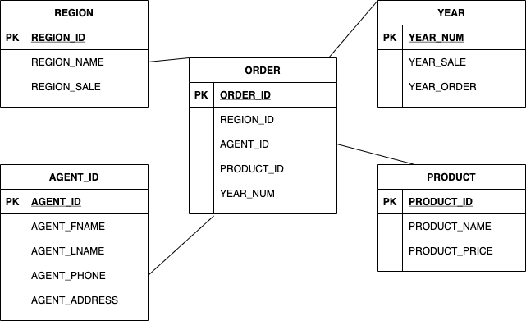

1. **Identify the attributes for the dimension tables that will be required to solve this problem.**

**Answer:**

YEAR: YEAR_NUM, YEAR_SALE, YEAR_ORDER

REGION: REGION_ID, REGION_NAME, REGION_SALE

AGENT: AGENT_ID, AGENT_FNAME, AGENT_LNAME, AGENT_PHONE, AGENT_ADDRESS

PRODUCT: PRODUCT_ID, PRODUCT_NAME, PRODUCT_PRICE

1. **Using Microsoft Excel or any other spreadsheet program that can produce pivot tables, generate a pivot table to show the sales by product and by region. The end user must be able to specify the display of sales for any given year. The sample output is shown in the first pivot table in Figure P13.2E.**

**Answer:**

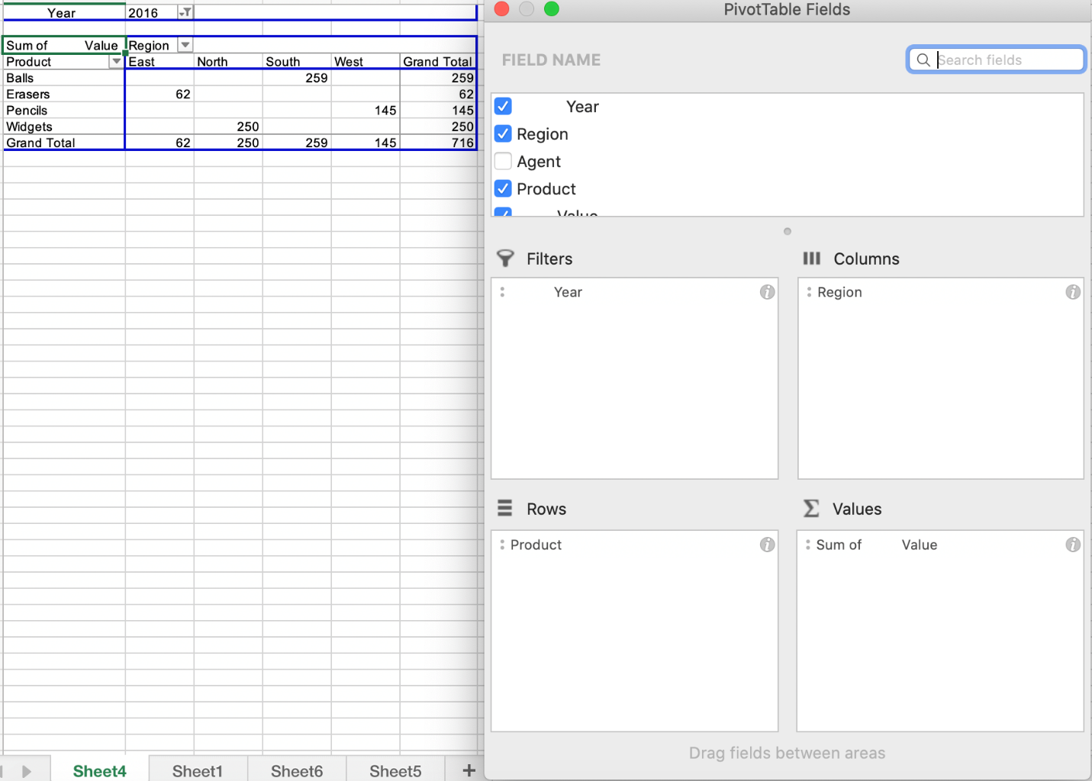

1. **Using Problem 2e as your base, add a second pivot table (see Figure P13.2E) to show the sales by salesperson and by region. The end user must be able to specify sales for a given year or for all years, and for a given product or for all products.**

**Answer:**

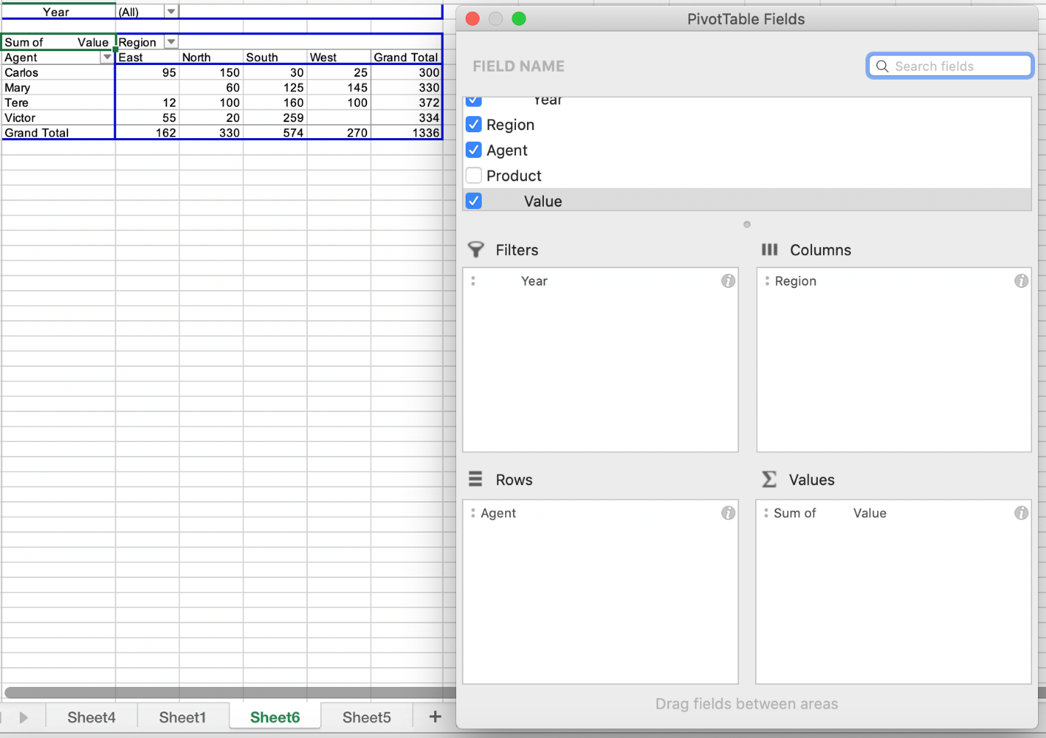

1. **Create a 3D bar graph to show sales by salesperson, by product, and by region. (See the sample output in Figure P13.2G.)**

**Answer:**

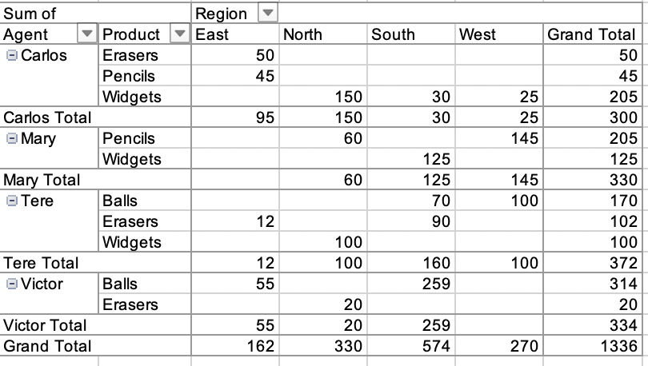

Based on this table the 3-D graph is as follows

